1. **Task Description:-**

The goal of this task was to create a **React component** that displays a list of items (such as employees) in a table, and allows users to **filter** the list dynamically by entering text in a search box..

1. **Task Output Screenshots:-**
   1. Home Page

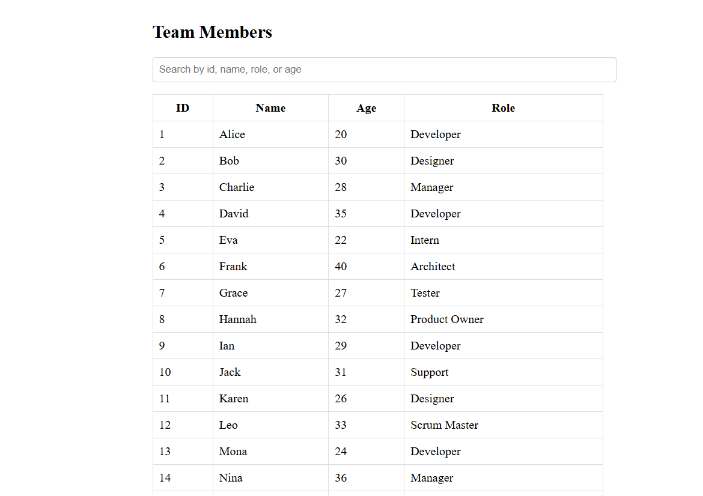

* 1. After input getting the data

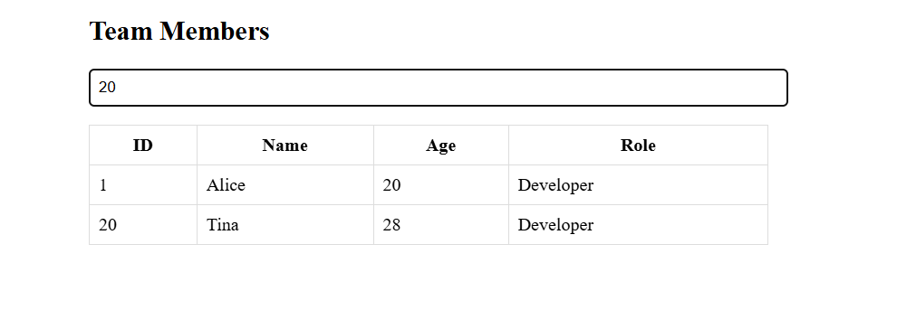

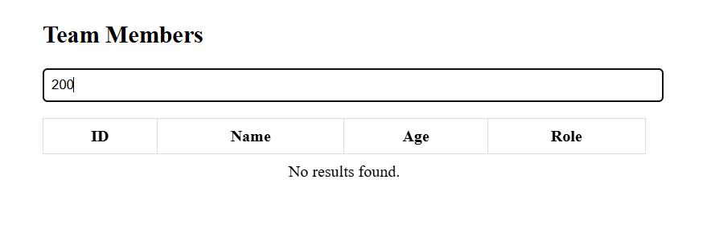

1. **Widget/Algorithm Used in Task:-**
   1. The TableFilter component is a functional component built with React.
   2. It uses a standard HTML table (<table>, <thead>, <tbody>, <tr>, <td>) to display data.
   3. A search input field (<input type="text">) is placed above the table to capture user input**.**
   4. The filtering logic is implemented using JavaScript’s filter() method:

const filteredData = data.filter(item =>

item.name.toLowerCase().includes(searchTerm.toLowerCase()) ||

item.role.toLowerCase().includes(searchTerm.toLowerCase()) ||

item.age.toString().includes(searchTerm)

);

* 1. The searchTerm is converted to lowercase to ensure **case-insensitive search**.
  2. The filter method checks whether the search term appears in:
     1. Id
     2. Name
     3. Role
     4. Age
  3. The table is re-rendered with only the filtered rows.